ENDURANCE/COMPETITIVE TRAIL RIDE REPORT FORM
Use this form for ALL non-MTRC rides.
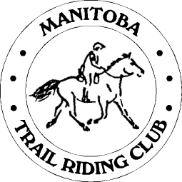
Manitoba Trail Riding Club
Complete this form and mail to Kelli Hayhurst
Box 53 Group 17 RR 2
Dugald, MB
R0E 0K0
Or e-mail to kelli@mymts.net

HORSE INFORMATION

Registry Type • AHR (Arabian Horse Registry) • IAHA (International Arabian Horse Assoc. • CAHR (Canadian Arabian Horse Registry)
Half-Arabian Horse Registry)
• AAHR (Anglo-Arabian Horse Registry) • CPAR (Canadian Partbred Arabian Registry) • Other (list breed)
Horse Registry Registration # Horse Name
(Indicate Registry from above list)

OWNER INFORMATION
Name _______

Address E-Mail

City Province Postal

Home # Work # Fax #

RIDER INFORMATION
Name _______

Address E-Mail

City Province Postal

Home # Work # Fax #

RIDE INFORMATION: Endurance Competitive
Ride Name

Location
City State/Prov.

Date Sanctioning Organization

Judge/Veterinarian Number of Starters (Total, all breeds)

Miles Completed Completion Position Best Condition Yes No

RIDE MANAGER INFORMATION
Ride Manager's Name

Address E-Mail

City State/Prov. Zip/Postal

Home # Work # Fax #

I verify the above mileage and placing is correct.

Ride Manager's Signature Date

